HOW TO - Webcontrol Rotary Encoder

1 - Allow sites to be reloaded with Internet Explorer Extension (in Microsoft Edge)
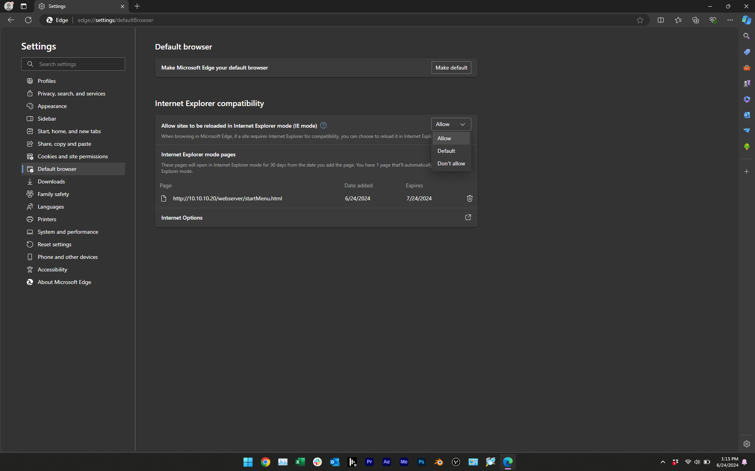

2 - Go to the main webcontrol site 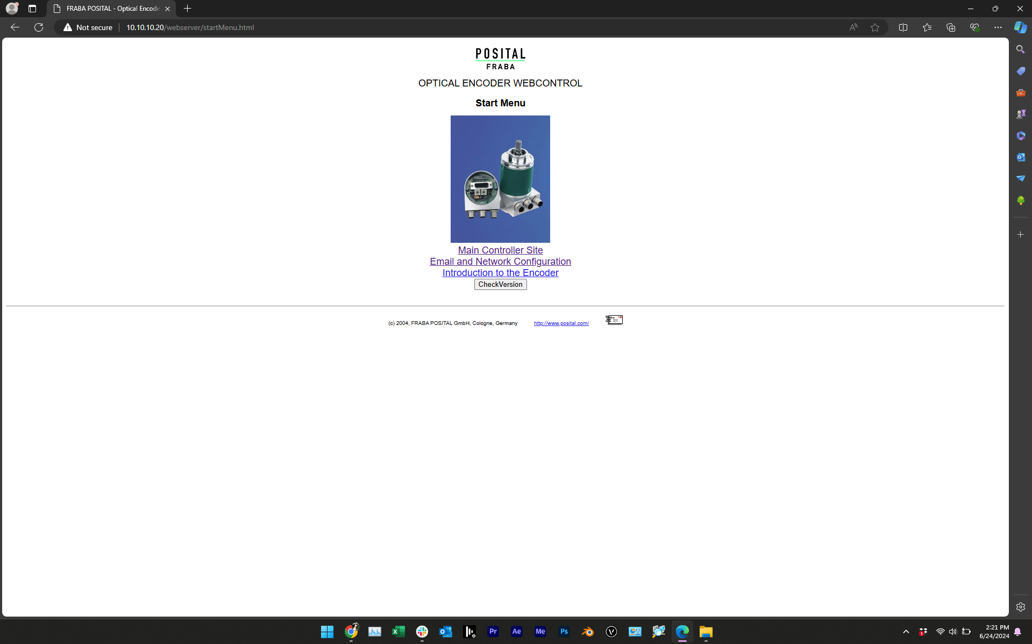

3 - allow both site-urls (“Main Controller Site” and “Email and Network Configuration” in Java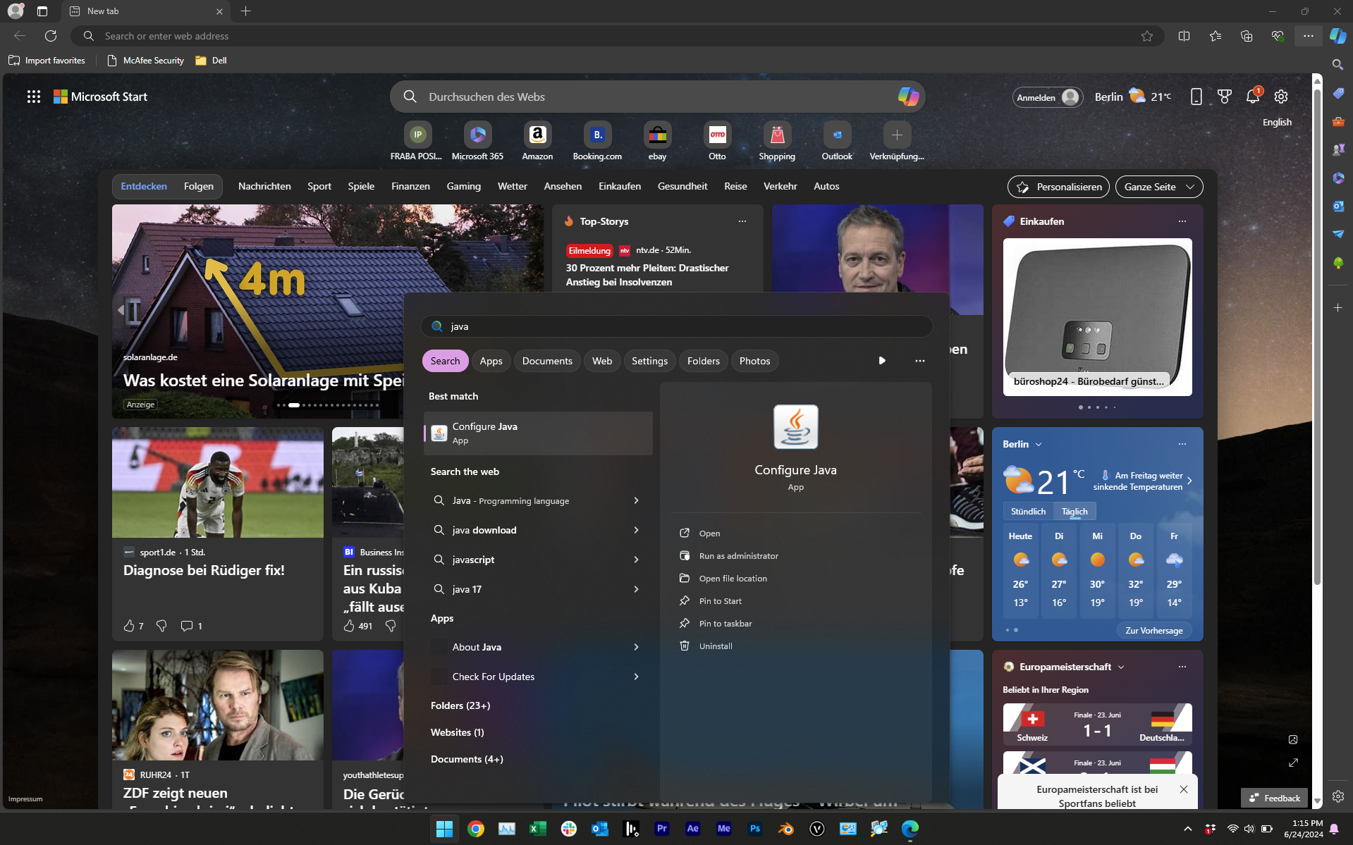

4 - see screenshot below
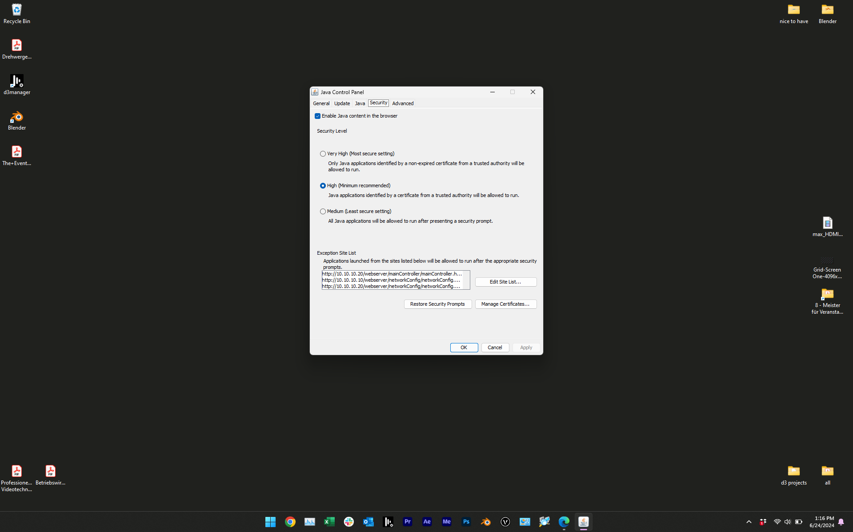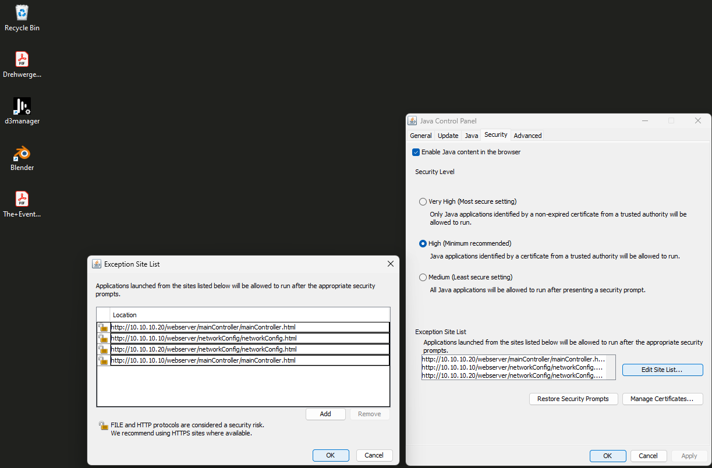
5 - now we reload the site in Internet Explorer 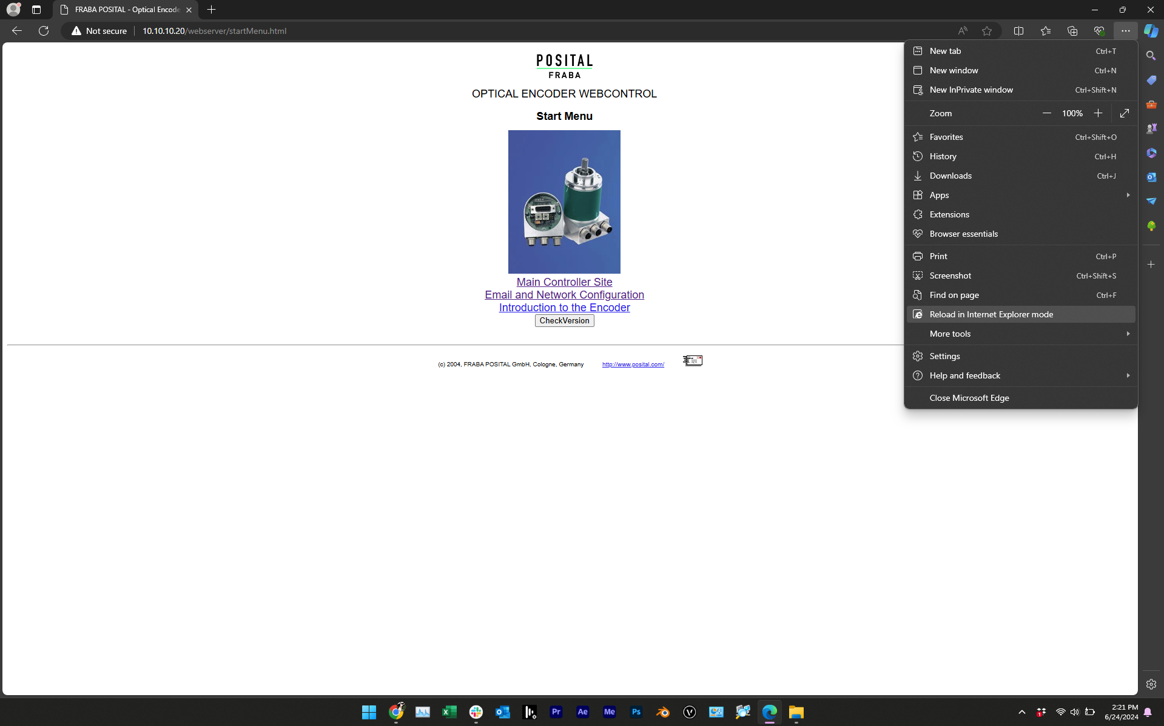

6 - click on “Later”
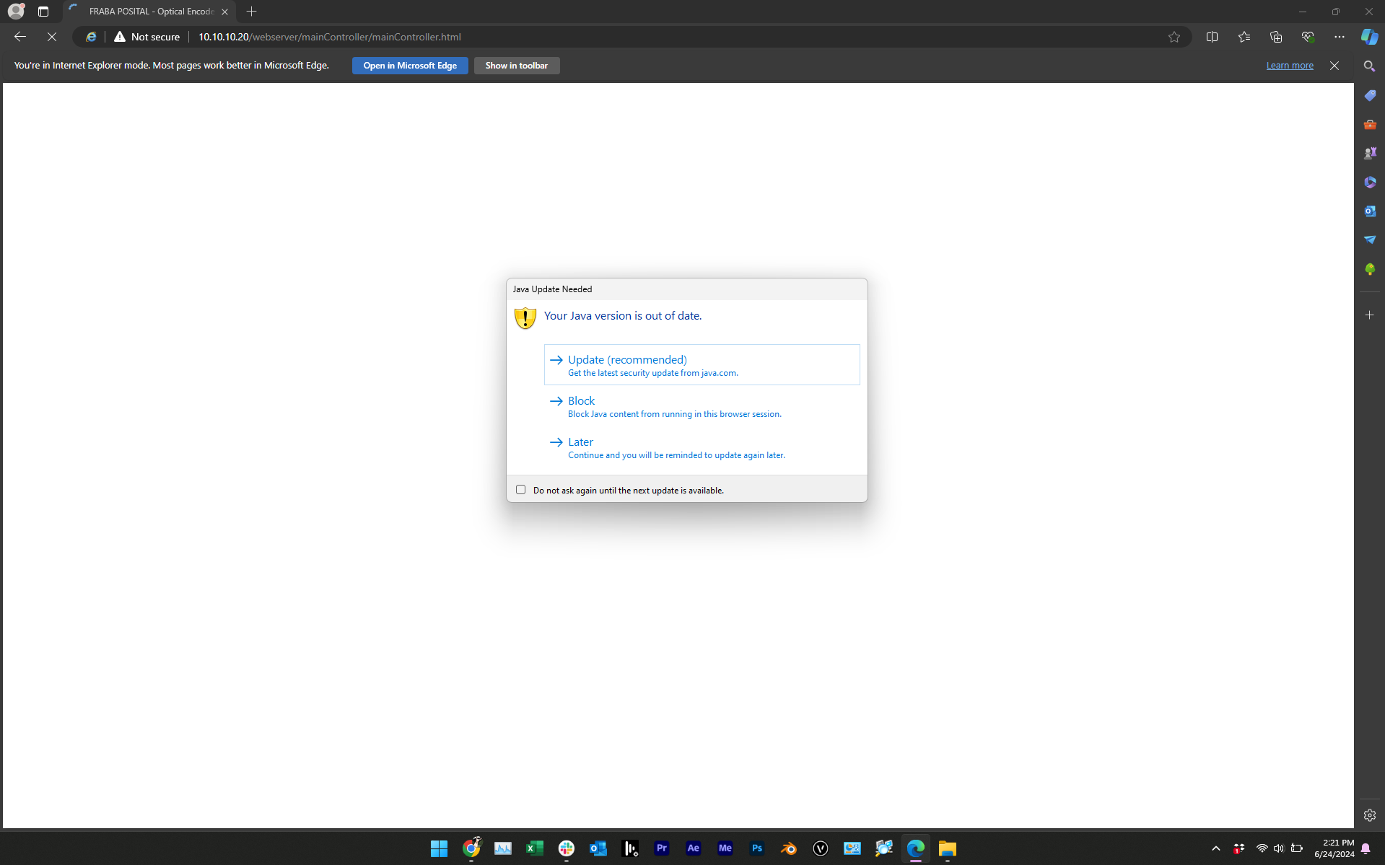

7 - Then you'll have to wait until the loading Java sign vanishes and we get an error message
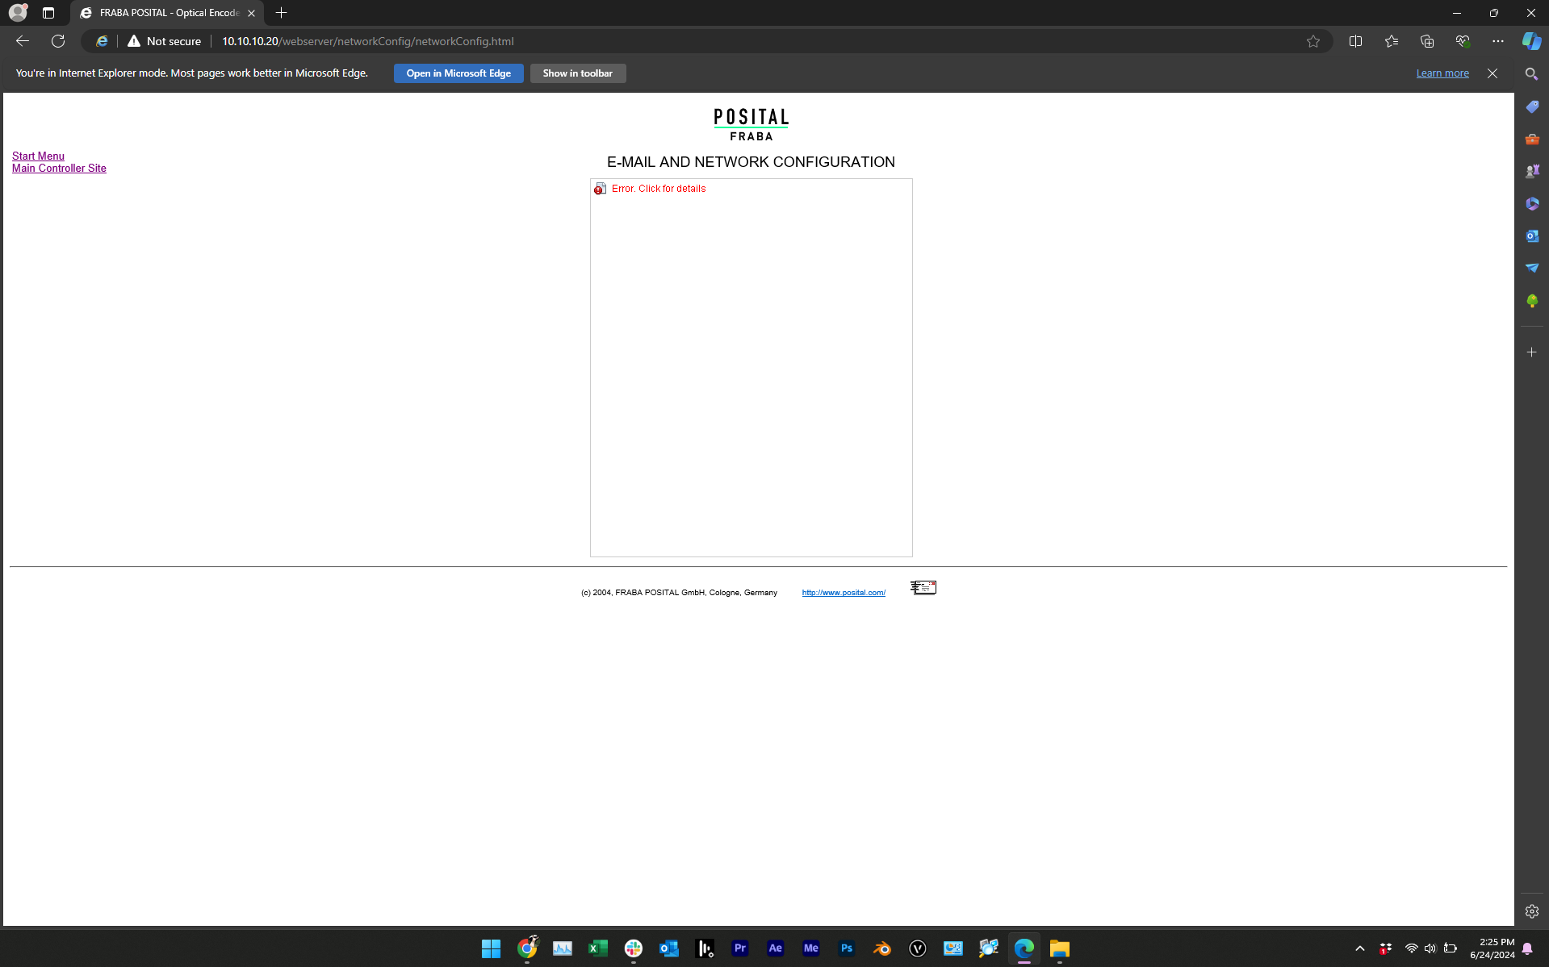

8 - Click on the link with the error and click on “reload”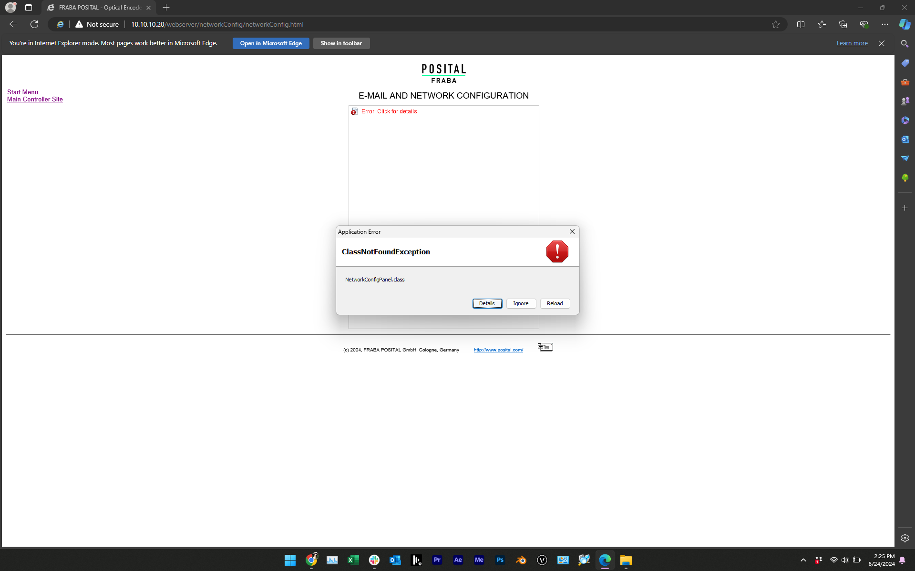

9 - click “Run” to finally run the controller web site
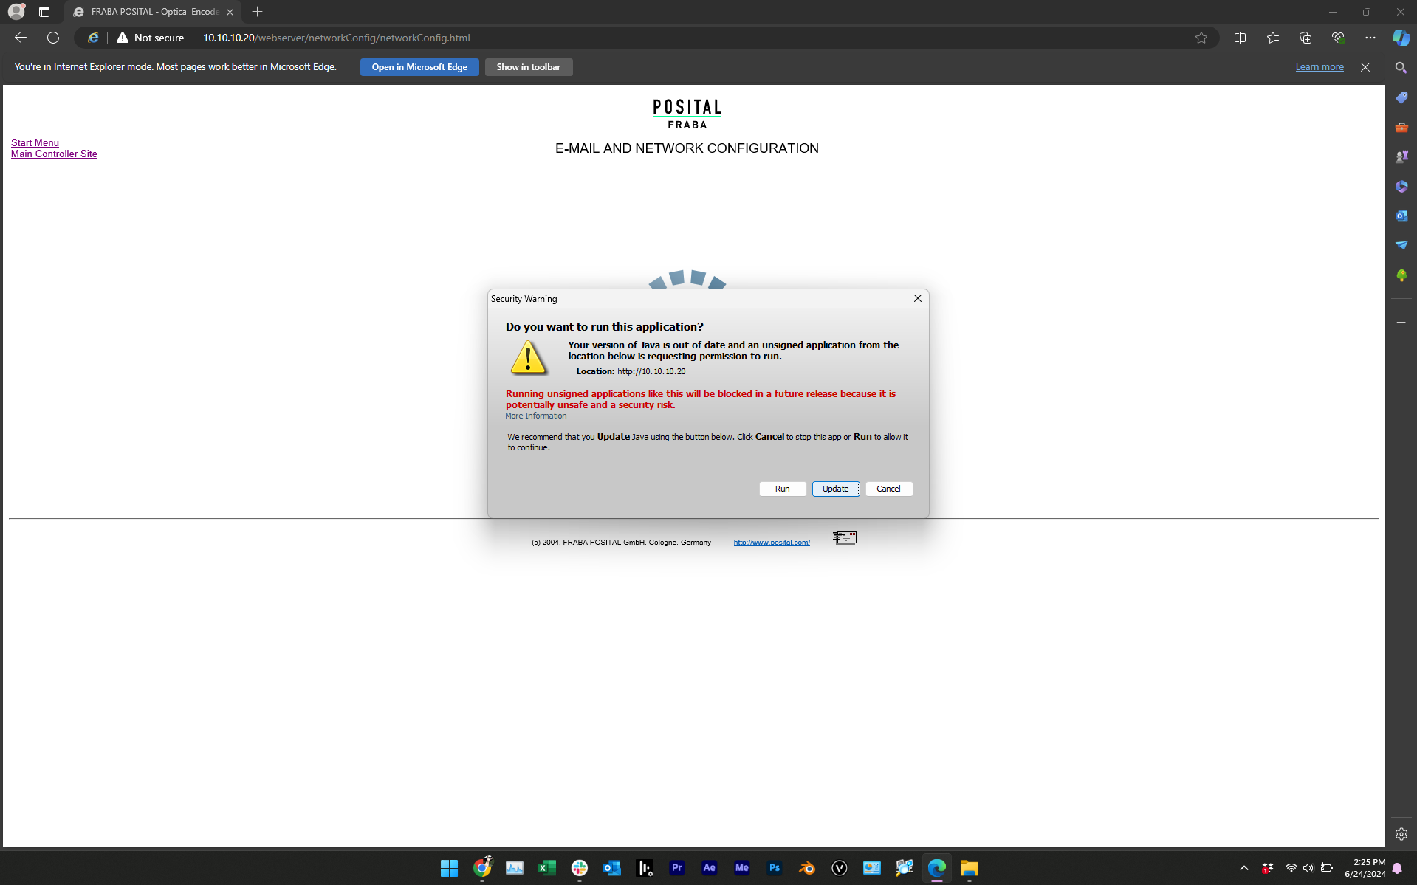

10 - done
